Chip back potential is the level which bulk silicon is maintained by on-chip connection, or it is the level to which the chip back must be connected when specifically stated below. If no potential is given the chip back should be isolated.

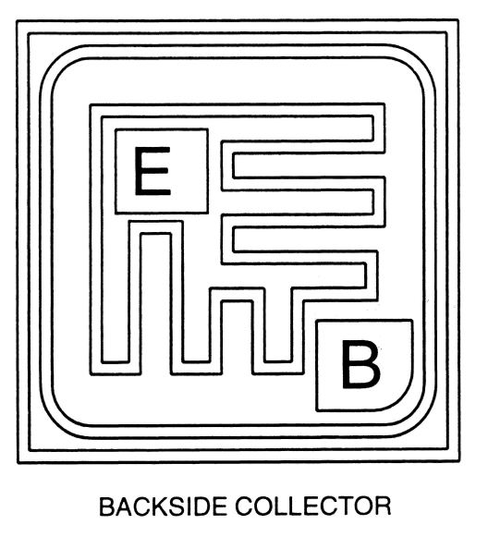

Top Material: Al
Backside Material: Au
Bond Pad Size: .004” X .004” min
Backside Potential: Collector
Process: CP316V

APPROVED BY: DK DIE SIZE .020” X .020” DATE: 1/22/20
MFG:CENTRAL SEMI THICKNESS .008” P/N: 2N5551
DG 10.1.2

Rev B, 7/19/02

